**Bamboo build steps**

* Before starting to go for build and deployment we need to have a repository created, based on that repository only bamboo build and deployment works.
* Create a stash repository for application which we need automate build and deployment.
* Open bamboo tool and follow below steps.
* Step1 : Create a plan

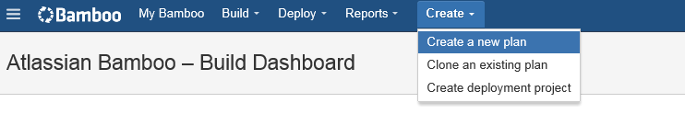

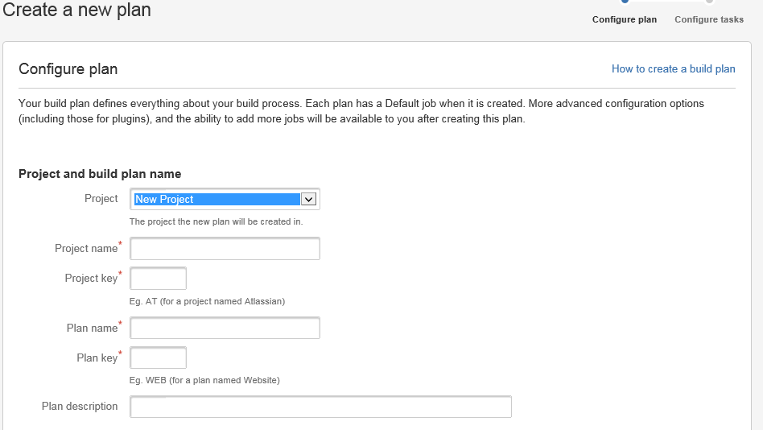 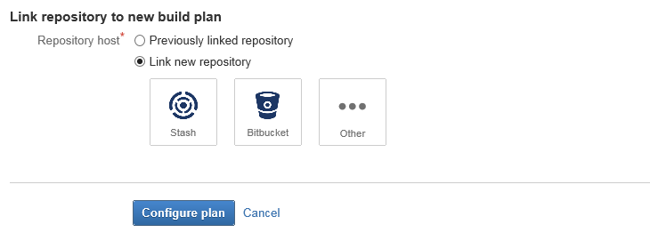

* Step 2 : Link your repository and click Configure plan.
* You will see the plan you created for build under build tag like below



* Steps 3: Click configure plan to edit or add any details like below

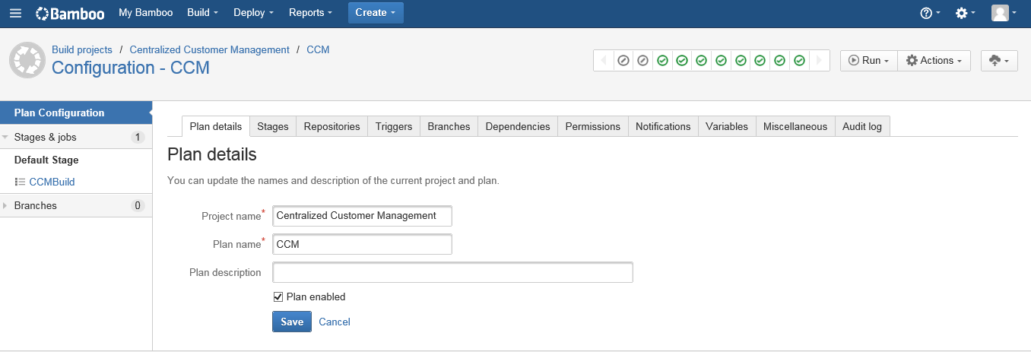

* Each and every tab is separate task need to be added.
* Step 4: Plan details , We need to mention project name and plan name as mentioned above.
* Step 5 : Stage : we are going to add the task like below 2 screens.

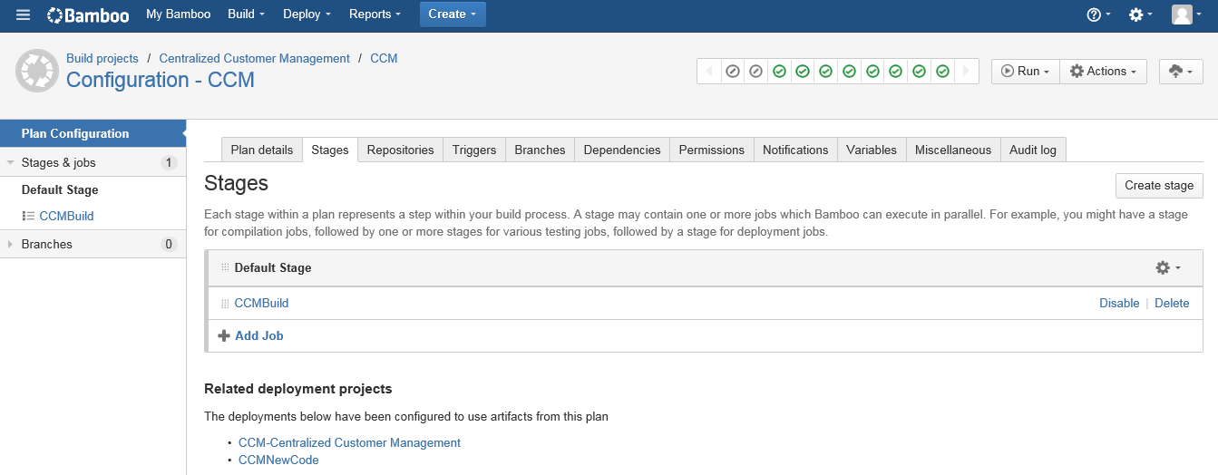

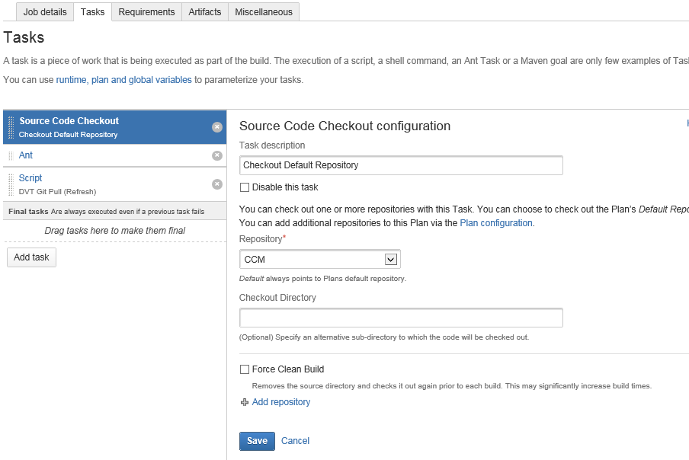

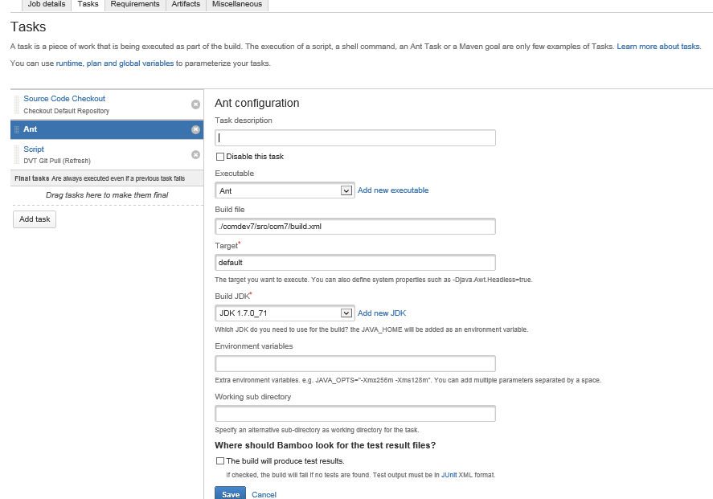

* We can add the script as per the requirements needed.
* 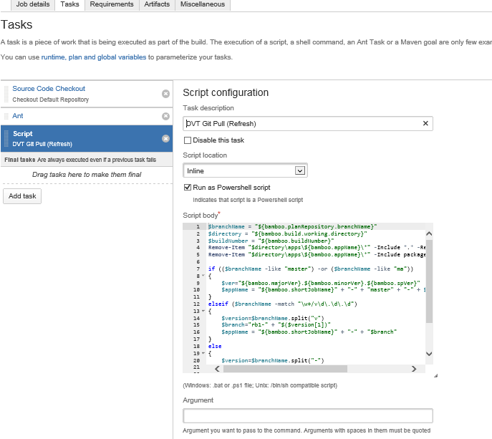

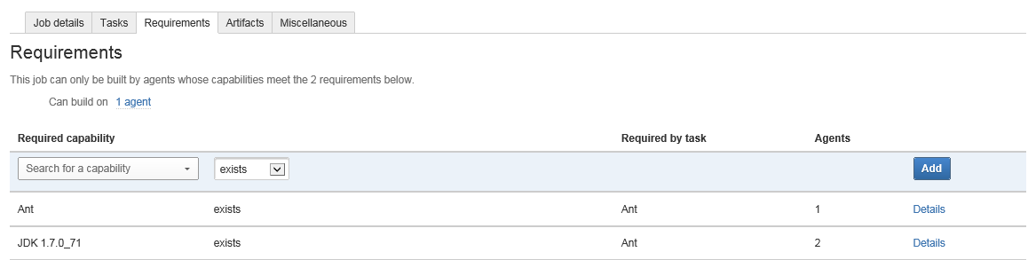

* Click create definition for artifact details

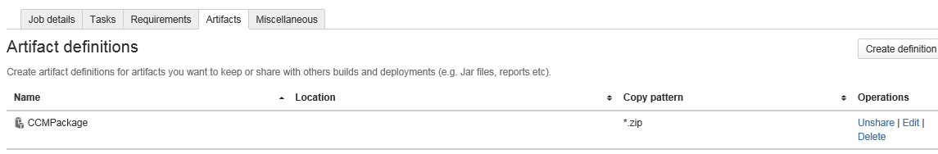

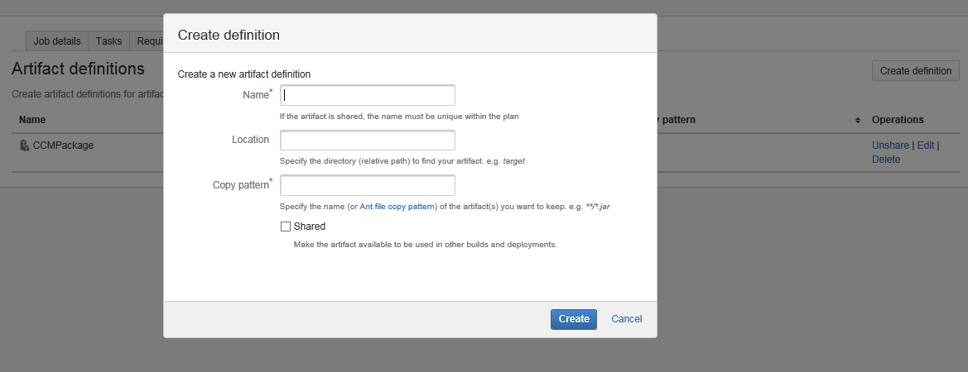

* Step 6 : Once above configuration done, we can run the plan. Once the build got successful you will see like below .

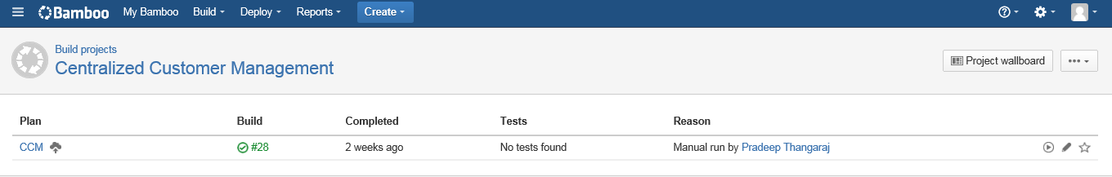

* It shows number of build for this application and its corresponding logs and ariticat.

